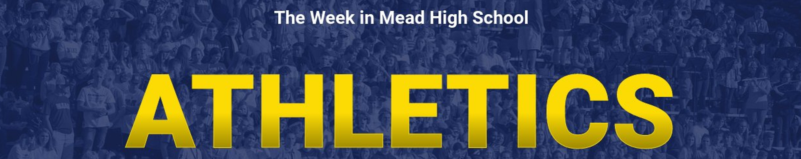
Follow @Mead_Athletics

4/24 – 4/29 Schedules

BASEBALL

4/24 – 9th v NC @ Pacific Park 4:00
C v Northwest Christian (DH) 3:30
4/25 – V @ University 4:00
JV v University 4:00
4/26 – 9th v Lewis & Clark 4:30
C v Mt. Spokane 4:00
4/27 – V v University 4:00
JV @ University 4:00
4/28 – V v Ferris 4:00
JV @ Ferris 4:00
9th @ Central Valley (DH) 3:30

GOLF
4/24 – Boys & Girls
@ Indian Canyon GSL #3 12:30
4/27 – Boys & Girls
@ Deer Park GSL #4 12:30

BOYS SOCCER

4/24 – C v Pullman @ Union 4:00
4/25 – C v LC @ Hart Field 4:00
4/26 – V v Lewis & Clark 6:30
JV v LC @ Hart Field 4:00
4/28 – V Ridgeline @ Union 4:00
JV @ Ridgeline 6:30

UNIFIED SOCCER

4/27 – Mead @ Deer Pard 3:00

SOFTBALL

4/24 – JV @ University 4:00
C v Mt. Spokane 4:00
4/25 – V v University 4:00
4/27 – V @ Central Valley 4:00
JV v Central Valley 4:00
4/28 – V @ Cheney 4:00
JV v Cheney 4:00
C v Ridgeline 4:00

TENNIS

4/24 – JV Boys @ Chewelah
4/25 – Boys v Gonzaga Prep 3:30
Girls @ Gonzaga Prep 3:30
4/26 – Boys @ Ferris 3:30
Girls v Ferris 3:30
C Girls @ Deer Park 3:30
4/28 – 4/29
Inland Empire Tennis Tournament

TRACK

4/27 – Boys & Girls – GSL #3
v Gonzaga Prep & Ferris @ Ridgeline 3:00
4/28 Boys & Girls @ Newport TBD
-------------------------------------------------------------------
For the most accurate & up-to-date TEAM SCHEDULES go to ARBITER LIVE. Or link to our Mead Athletics Page

April 24, 2023 ATHLETIC SCHEDULES

BASEBALL – The Panthers are 9-5, and with just 4 games remaining in the regular season, are in 3rd place in the overall Greater Spokane League standings. The Boys picked up a win over Lewis & Clark (15-5, 5 innings) on Tuesday and swept the Bears at the end of the week, 8-5 & 10-9. Against Central Valley on Thursday, Max Workman and Ty Webb each had 2 hits and David Barnes homered. Friday, in the valley, Emerson Fleck had 3 hits.

BOYS SOCCER – Anthony Vang scored in the first minute, Kye Welch scored twice and Ryan Taigen had a goal and 2 assists in Mead’s 5-0 win over University on Wednesday. Friday, at Gonzaga Prep the Panthers and the Bullpups went to a shootout after 90 minutes and no goals scored. The Bullpups won in a shootout, 1-0 (4-3). Mead is 6-1 in GSL play with 2 regular season games left on the schedule.

FAST PITCH SOFTBALL – Mead (10-2, 3rd place) picked up three wins last week. Tuesday at Ferris, Sierra Wyatt, Campbell Brose and Charlie Stern all had 3 hits. Stern homered twice and drove in 8 runs in a 25-7 win. Thursday, against Lewis & Clark, Brose and Jaycee Coffield combined for 7 hits and 8 RBIs in a 24-0 win over the Tigers. On Friday the girls won 11-1 at Ridgeline. Alanna Tomayko had 2 hits and Stern homered.
BOYS & GIRLS TENNIS – Tuesday, the Boys (6-0) defeated Central Valley, 7-0 and on Thursday they had a big team win over previously undefeated Lewis & Clark, 4-3. For the Girls (5-1), they won twice last week as well. 5-2 over CV and 5-2 against the Tigers.

GOLF – GSL Match #2 – The Boys finished 1st as a Team and our Girls were 3rd at their second League match of the year played at Esmeralda Golf Course. Thursday, the Boys played at the Palouse Ridge Invitational and took home the Team Title, edging out West Valley of Yakima, 293-298. Ben Barrett’s 66 was the low round of the day! The Girls played at the Eleen Northcutt Invitational on Friday (Wandermere) and placed 2nd. Brook Bloom’s 76 was the low round for the Panthers.
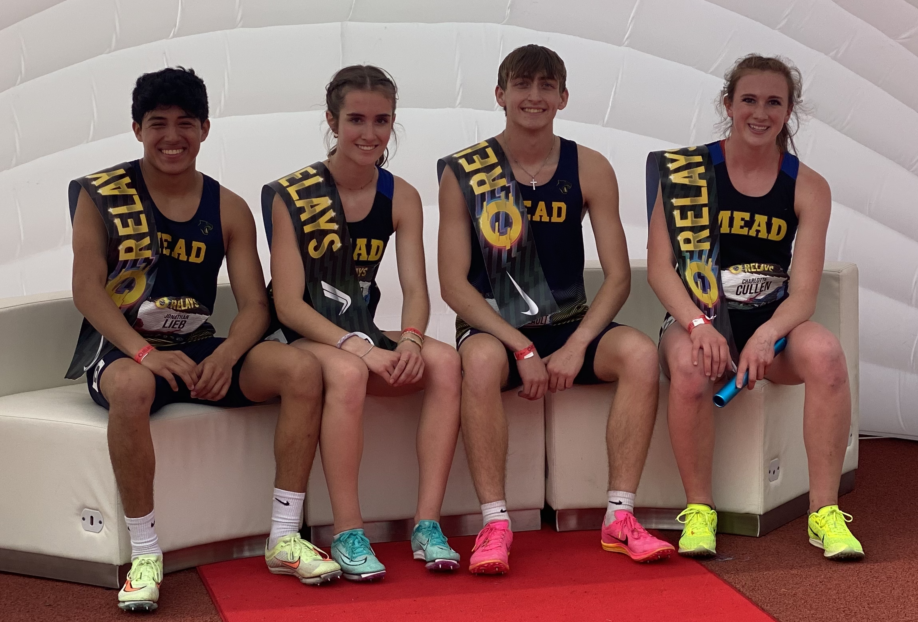
BOYS & GIRLS TRACK – GSL Meet #2 – Both teams improved to 4-0 in regular season meets, with wins over University and Cheney at Cheney on Thursday.
Boys Team Scores: Mead 96 – Cheney 49, Mead 108 – University 28
Girls Team Scores: Mead 111 – Cheney 39, Mead 103 – University 47
Mead High School had competitors in this weekend’s Oregon Relays at Hayward Field in Eugene, Oregon and the Panthers showed well.
Boys 4 x 100m Relay, Johnny Talarico, Zealand Franklin, Drew Menck, Dominick Corley –3rd. Javelin, Evan Berg – 4th. Pole Vault, Kadmiel Lopez – 8th.
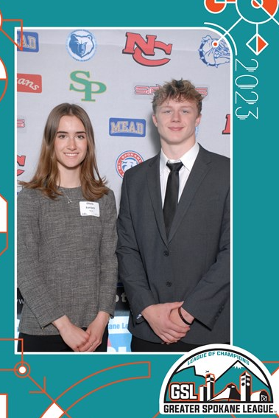
Girls 800m, Charlotte Cullen – 4th. Discus, Cassie Moeller – 16th. Javelin, Moeller – 3rd. Pole Vault, Dezlyn Lundquist – 26th.
AND . . . . The 4 x 800 Mixed Relay Team of Jonathan Lieb, Olivia Ferraro, Jacob Marchesseault and Charlotte Cullen won their event by 10 seconds and posted an unofficial, high school record time of 8:44.74 ! CLICK THE LINKS BELOW FOR MORE ON THEIR RACE. RUNNERS COACHES

GSL Scholar Athlete Luncheon – Olivia Ferraro and Chris Grosse are Mead High School’s 2023 GSL Scholar Athletes of the Year. They were 2 of 32 GSL senior student-athletes recognized at Thursday’s Luncheon held at Center Place Event Center in the valley.

ACADEMICS TEAMWORK COACHABLE TRUST EXCELLENCE

